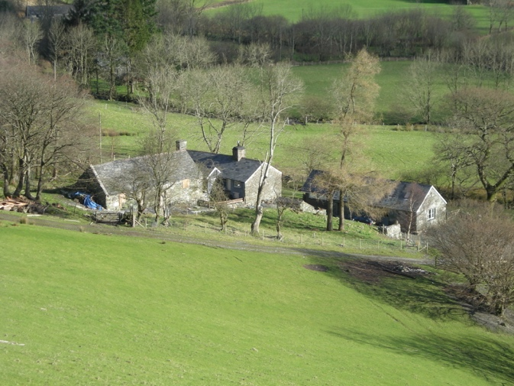
Gesail Farmhouse and Barn
Snowdonia

Terms & Conditions for staying at Gesail
We will try at all times to be accommodating, fair and flexible. We do however need to establish these conditions to make sure your stay is enjoyable for all.
This is a legally binding contract between the property owner, Raynes Minns and the holidaymaker. The property owner is also referred to as "we" and "us".
The holidaymaker is the person who signs the booking form or, in the case of online booking, the person who makes the online payment. This person is responsible for ensuring all members of the holiday party accept and adhere to these terms and conditions. The holidaymaker is also referred to as "you".
The property referred to being is Gesail Farmhouse and Barn.

The contract is for a short-term holiday rental and shall be made between the guest and Gesail. A contract is only entered into once the booking and deposit has been processed and a confirmation email issued. Gesail is a fantastic place for a gathering of friends and family and we want you to have a great time here.

1. Reservations and cancellations
50% of the rental fee is payable on booking and this reserves the property for you and the remaining balance must be paid 8 weeks before the visit. Non-payment of the final balance when it becomes due will constitute cancellation of the booking and forfeiture of the deposit payment. We require a breakage deposit of £250 via a bank transfer or credit card with your final balance.
You must be over 18 years of age at the time of making your booking.
Cancellations: If the house can be re-let at the same rate, you will receive a refund of amounts already paid, minus a £30 admin fee. If the house is re-let at a lower price, you will receive the lower rate minus a £30 admin fee on the amount you originally paid. There will be no refund for cancellations if the house cannot be re-let for a price acceptable to us for the booked period. We advise you to take out holiday insurance that includes cancellation compensation for accommodation and covers risks such as flight cancellation and any unusual events.

If you have a complaint you must bring this to our attention straight away. Complaints must be dealt with during your break and will not be considered after your departure. Please note that the accommodation is strictly a no-smoking environment. We very rarely get people ignoring this, but if you choose to we reserve the right to charge for specialist cleaning and to ask you to leave the property immediately.

CANCELLATION BY US
We reserve the right to cancel your booking at anytime in the event of circumstances beyond our reasonable control. In the unlikely event of this happening, we will refund all money received by us in relation to your booking of the property. However, we will not be liable for any other loss incurred by you as a result of the cancellation.

COVID 19

If we are required by the Government to close due to the coronavirus pandemic we will need to cancel your holiday. You can either choose to move your holiday to another date or receive a full refund.

If you live in an area that is in a local or national lockdown and you are therefore unable to travel to Gesail, I will need to cancel your holiday. You can either choose to move your holiday to another date or receive a full refund.

If you have to cancel your holiday for any other reason, including if you fall ill with coronavirus or are required to self-isolate, I will be unable to refund any payments so I strongly advise that you take out holiday insurance. If I can re-let your holiday dates, I can re-fund you, minus a £30 administration fee.

If you fall ill with COVID 19 during your holiday you will need to travel home to self-isolate as soon as possible. It is essential that you let us know if you, or anyone else in your party, becomes ill so we can clean the property appropriately.

GENERAL INFORMATION REGARDING BOOKINGS
Our self-catering accommodation is suited to and equipped for families and friends. We reserve the right not to accept bookings from anyone whom we feel the accommodation would not be suitable for. All guests must be listed and this sent by email eight weeks prior to arrival. Additional guests are not permitted unless agreed beforehand and the fee adjusted.
2. Payment
A bank transfer should be sent to our UK bank account or we can accept card payments via the website. For within-Britain bank transfers there are no bank charges but for international electronic bank transfers, bank charges tend to be around GBP£20, although there are occasionally intermediary bank charges in addition. The amount received by us should correspond with the amount invoiced.
3. Advertised rental price

Prices may vary: after you have booked, prices on the websites may show as higher (if demand becomes very high) or lower if, sometimes close to the start date, we reduce the price for ‘special offer’ late sales. Price changes do not affect your booking, once your deposit is paid and the property is reserved for you.

4. Arrival / departure
Arrival after 5.00 pm (unless earlier check-in previously agreed)
Departure by 10.00 am (unless later checkout previously agreed)
It is important that you stick to your arrival and departure times, as we need the time to get the property ready for the next arrivals. A few times our housekeeping team have been inconvenienced by guests not leaving on time and so we have regretfully decided that any overstay will be charged at £40 per hour or part thereof. This will be deducted from the ‘breakages’ deposit.
5. Cleaning & linen
Tea towels and hand-towels are provided in the kitchen and both bathrooms, as are bathmats and soap. Please bring your own bath towels.
The beds are made up with fresh linen.
The house is presented freshly cleaned and should be left in good order.
6. Parking

There is plenty of space to park. However guests need to drive over a ford through a stream about 100 meters before the property.

7. Telephone and internet access

There is no mobile phone signal in the valley and you won’t get any reception. However, we have very basic satellite Wifi in the barn (password in barn instruction book) and this can be used for emails, WiFi assisted calling or to send What’s App messages. The Red Lion Pub is only a few miles away in Dinas Mawddwy and there are many cafes in Dolgellau and the surrounding area where you can go for coffee and to check emails .

8. Smoking
The NO SMOKING ban in England and Wales now makes it illegal to smoke inside the house. Please observe this rule.

9. Pets
Your pets are very welcome. Please keep dogs on a lead whilst in the fields with sheep and lambs and also help our housekeeper by wiping muddy paws before coming back into the properties.
We also ask you to keep your pets off the beds and sofas and to pick up any dog poo in the garden. If your dog is used to going on the sofa at home we ask that you please bring your own throw to put on the sofas at Gesail.
Please let us know at time of booking if you are bringing any animals.
10. Surrounding wildlife

Gesail is set in an idyllic rural location where there is an abundance of fabulous flora, fauna and wildlife. If you are lucky you will be able to spot bats flying in the woodland at dusk. Whilst we do everything we can to prevent any wildlife entering the barn and farmhouse, as with any house in the countryside, we cannot guarantee that occasionally small creatures won’t find a way in.

11. Personal safety and holiday cancellations

Guests are advised to take out travel insurance. We accept no liability for guests’ illness, hurt or loss/damage to personal property during their stay, or for any circumstances (e.g. flight cancellations, illness) that prevent guests from arriving at the property, other than those caused by ourselves.

The property owner takes no responsibility for the personal possessions of the holidaymaker or the holidaymaker's party. Vehicles and possessions are left entirely at the risk of the holidaymaker.
Children must be supervised at all times.

12. Hairdryers and other electrical goods

There are two hairdryers. We also leave adaptors so you can plug in appliances from overseas but DO REMEMBER that you will need transformers for US appliances. If you do not find the adaptors you need (they sometimes ‘walk’) you will be able to buy them at local shops.

13. Cleaning up before you leave

We arrive as you leave, to strip the beds and clean the House and Barn thoroughly. However, you are expected to leave them in good order – tidy, dishes washed up, floors swept and mopped if they’ve got especially muddy or sticky from a spilt drink, oven and fridge cleaned. Please remove all rubbish to the bin down valley as per the instructions in the House and Barn.

The instructions are in the House and Barn about turning the thermostat timer on for the hot water and heating. The timer is generally set from 7am to 11am and then from 3pm to 11pm but you can put it on constant or adjust as you wish. HOWEVER PLEASE TURN IT TO OFF before you leave.

14. Occupancy

The property may only be occupied for the purpose of a holiday.
The property may only be occupied by the number of the guests stated when you booked. If you wish to amend the number of guests in your party, this must be agreed in advance of your stay.
When listing guests please add them all (including infants) in the email. A maximum of 10 guests may occupy the house and under no circumstances can you invite outside guests round to the property (unless previously agreed). We reserve the right to refuse entry or ask the entire group to leave if this condition is not observed.
GUESTS OBLIGATIONS AND RESPONSIBILITIES THE GUEST AGREES:
- To keep the property it’s fixtures and fittings in the same and proper condition and repair as on arrival.
- To remain responsible for all children, pets and adults requiring care at all times.
- To pay for any damage or loss incurred during the occupation excluding reasonable wear and tear. All breakages and any damage must be reported to us before the end of your holiday.
- We ask you not to cause nuisance or annoyance to occupants of any nearby properties during your stay. To this end we ask that there is no loud music outside.
- If damage caused results in the houses being un-fit for occupation to subsequent guests you shall be liable for the loss of rental income and any other related losses.
- We shall not be responsible for any loss or damage to any belongings or injuries sustained by you or any member of your party.
RIGHT OF ACCESS
You must allow us and our representatives access to the property at reasonable times for the purpose of inspection, or to carry out any repairs or maintenance.
SHOULD YOU ENCOUNTER A PROBLEM
We hope you will never have any cause for complaint. In the event that a problem occurs please contact us as soon as is possible while you are at the property so that we can make every reasonable effort to assist you and to resolve the issue.
CLEANING SERVICE
Should you prefer us to provide a cleaning service on departure, we can do so for a fee of £100. This must be pre-booked and prepaid prior to arrival.
Return of Breakage Deposit
Your breakage deposit, minus any deductions, will be returned to you within 7 days of the departure.

I HAVE READ, UNDERSTOOD AND AGREE TO THE TERMS AND CONDITIONS
SET OUT ABOVE …………………………………………
Date …………………………………..
Address ………………………………
Phone number …………………………….
Please let me know if you intend to bring any dogs and how many:

Please list all guests staying at the property:

How did you hear about us?

